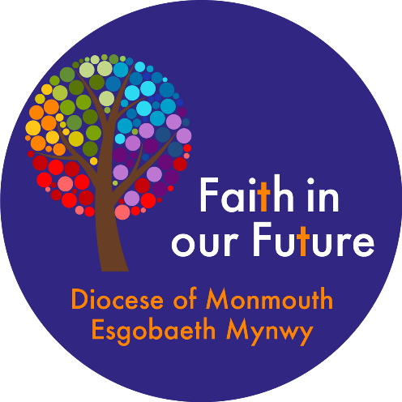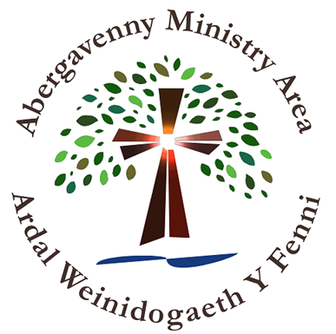

Profile for the post of
Team Vicar
in the
ABERGAVENNY
MINISTRY AREA



Introduction from the Archdeacon of Monmouth

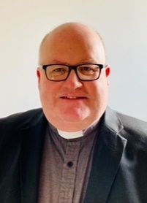
Dear Friend in Christ,
Thank you for looking at the profile outlining the role of Team Vicar in the Abergavenny Ministry Area (MA). I am delighted that you are considering this key post in our diocese which is full of potential and possibilities for ministry.
This is a wonderful place in which to live and work; steeped in history and set in the beauty of the Welsh countryside. God has been at work here for centuries and the former Benedictine Priory of St Mary’s, along with the other town churches and the ancient church buildings of the surrounding villages, stand as signs and symbols of God’s activity through Christian mission and witness down the ages. We are looking for someone to continue that work as part of our team; a priest who has been captured and transformed by the love of God and seeks to share that with others, with a real enthusiasm for outreach and a vision for trying new things as well as treasuring what we have.
Thanks to the hard work of many, solid foundations have been laid in terms of the new governance structure and financial operations of this group of churches. We have recently appointed Reverend Lea Ryder to be the Ministry Area Leader (Rector and Area Dean) and this has created the vacancy for the Team Vicar. We are seeking a faithful priest who can work closely with the ministry team and enable the people of God to become all that God calls them to be. Prayer and worship will be central. Mission, outreach and service will flow out from that into the communities, schools and homes of the places that form this Ministry Area. The seven congregations are beginning to capture the vision and to work and share together. It is a really exciting time for the Ministry Area and they are looking forward to the hopeful and exciting future that God has in store for them.
As a diocese, we are intent on developing a culture of openness, honesty and transparency, mindful that everyone works best when there is mutual support, trust and respect. We place great importance on good teamwork at every level of our diocesan life where people share leadership and responsibility, and everyone is encouraged and supported in using the gifts that God has entrusted to them. We seek to demonstrate this in the Bishop’s Staff Team and the Diocesan Office as well as in our Ministry Areas.
If the prospect of all this excites you and sounds like something that you want to be part of, then please do apply. The successful applicant will be well supported by the laity and by their ministerial colleagues at local and diocesan level.
May God bless and guide you as you discern his call on your life.


Our new Vicar:

We are looking for someone who:

• Is grounded in prayer and can embrace the different traditions in the Ministry Area;
• Is enthusiastic for outreach with a vision for new ideas, recognising that churches can grow, and someone who will inspire others with that belief and vision.
• Has a pastoral heart and possesses good relational skills;
• Is well organised and a team player;
• Will work with the Ministry Area Leader to share the MA’s vision with colleagues, church members and the wider community;
• Is a good communicator;
• Understands the context of rural and urban communities with the desire to embrace the challenges and opportunities for mission and service;
• Is able to maintain a good work/life balance;
• Has the ability to build relationships with colleagues, church members and the wider community, including working with the schools engagement pioneer to minister with children and families;
• Has a passion for encouraging members of each of our congregations in discipleship;
• Will help foster vocations to both lay and ordained ministry and release the gifts of the whole people of God;

We are excited about the gifts a new Team Vicar will bring and hope that you will be excited about working in a friendly, supportive, enthusiastic and encouraging team who have a wealth of experience and a real passion, both for the area and for sharing the gospel in this area.

Some background about Ministry Areas and our local area

Ministry Areas
The Diocese of Monmouth, along with the rest of the Church in Wales, has restructured into Ministry Areas. There are 16 across the Diocese and these are organised as Rectorial Benefices (Team Ministries) with each Ministry Area having a ministry team which works collaboratively with each other and local congregations. The Ministry Area has a Ministry Area Council with licensed clergy and elected representatives from the local churches. Each church has a Local Church Council to which much of the day-to-day responsibility is delegated by the Ministry Area Council. The Ministry Areas have also been adopted as the Deaneries in the Diocese so the Ministry Area leader is also the Area Dean.

The Abergavenny Ministry Area
The Ministry Area encompasses the town of Abergavenny, named this year as the Best Place to Live in Wales by the Sunday Times, and the villages of Govilon, Llanfoist, Llanellen, and Llanwenarth Citra. Having been commissioned on January 8, 2023, we are still a relatively young MA but, during that time, and in the transition period beforehand, the seven churches have grown closer together. This is something we are looking to continue to develop.

Our congregations readily attend shared services, whether for special occasions or for rota management reasons. We have run MA Lent and Bible study sessions and our Open House service, on the second Sunday of the month, draws families from throughout the MA for prayer, praise and fun. There is a variety of worship across the MA.

Much has been achieved in creating a sense of collaborative working. Our meetings routinely start with a celebration of the Eucharist which draws the Trustees (the Ministry Area Council) together in the work of the Ministry Area. We have undertaken various development days and training together (team formation, stewardship, safeguarding, exploring lay ministry) which has enabled each Trustee to develop a good understanding about the challenges and opportunities we all share. We are currently in the process of registering as a Charitable Incorporated Organisation (CIO) and have been working closely with the Diocesan Officers on this process.

Our new Ministry Area Leader, the Revd Lea Ryder, was appointed in September this year and we now seek to appoint a Vicar to replace her in that role. The MA also has a Curate, who started with us in July this year and our bid for a Schools Engagement Pioneer has been approved; we are hoping to be able to advertise this post shortly. The ministry team is complemented by retired and licensed lay ministers with permission to officiate. They are supported by two MA Wardens (one of whom also serves as Lay Co-Chair). There is a wide range of worship styles, from choral Anglo-Catholic to charismatic catholic via ‘middle-of-the-road’ traditional Anglican, with Matins, Eucharist and Evensong offered. The Ministry Area employs four members of staff – the Rector’s PA, a sub-organist, a facilities manager and a cleaner.

As with many areas, we have an aging church population but there are pleasing signs of growth among families and young people, with our Open House service, the choir at St Mary’s and more young people at the 11am St Mary’s Eucharist. With the schools engagement pioneer planned and a team ready to work with children and young people we are looking forward to seeing what God will do in this area. While we welcome these signs of growth among younger worshippers, we recognise that all members of our congregations need support to deepen their discipleship, and we seek to meet the changing spiritual needs of older people. It would be a hope that small groups could meet throughout the year, recognising that these help people considerably in deepening their journey of faith.

Most of our churches are used by the communities for concerts or drama, including Riding Lights, and several are used by schools, with St Mary’s in particular booked for most of December for school and charity events. We are becoming more involved in our local schools, in assemblies and to complement some Religious Values and Ethics lessons.

The Area

Abergavenny is known as the Gateway to South Wales, with the town on the edge of Bannau Brycheiniog (Brecon Beacons National Park) and with part of the Ministry Area in the Park itself, with its amazing walks and activities.

With a population of just over 14,000 people, the vibrant market town of Abergavenny maintains many links to the surrounding farming community. Superficially, the town appears affluent and comfortable, and yet it contains one of the most socially deprived wards in Monmouthshire. It is a town of great contrasts, and yet retains the feel of real community, has a strong civic tradition and a reputation for friendliness.

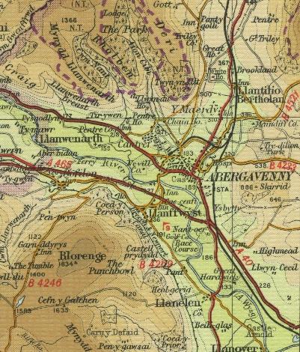
There is one all-through school in the town, King Henry VIII (ages 3-19) which was created in 2023 from the amalgamation of the former King Henry VIII Comprehensive and Deri View Primary schools. Within our ministry area, there are four other primary schools, including one Roman Catholic VA school and one Welsh-medium school. On the outskirts of the town (but in a different ministry area) is a Church-in-Wales VA primary school.

The town is a popular tourist destination, particularly well known for its annual Food Festival which takes place each September and draws in many thousands of visitors for the weekend. Transport links are good to the rest of the UK, with a regular train service and the M4 motorway only 30 minutes’ drive.

The village of Govilon is situated approximately three miles west of Abergavenny and has a population of approximately 1,500. It is situated at the base of the Blorenge, parts of which are within the Blaenavon Heritage Site, and the Brecon and Monmouthshire Canal flows through the village. There is a village shop and pub. It is a village which is growing with new housing under construction.
Situated about three miles south of Abergavenny, Llanellen is home to about 500 people. It is also at the foot of the Blorenge mountain while the Monmouth and Brecon Canal passes by on the hillside above. Apart from a well-used village hall, St Helen’s church is the only public building left in the village.
Llanfoist has within it a local Housing Association estate and several new estates of private houses. The remainder is a mix of private housing and some older council housing, some of which is now privately owned. The population is made up of a mix of all professions and numbers approximately 1,500 people. There is also a private nursing home and a primary school. There is a small church hall and larger village hall, the latter next to a popular garden centre.

The village of Llanwenarth Citra is about a mile west of Abergavenny and sits in lush grassy pastures between the Blorenge and the Sugar Loaf mountains. Some of these meadows have been designated a Site of Special Scientific Interest. The busy A40 Abergavenny to Brecon passes along the valley side above the flood plant of the River Usk and Nevill Hall Hospital is situated close by. The area is popular with walkers.
Our churches
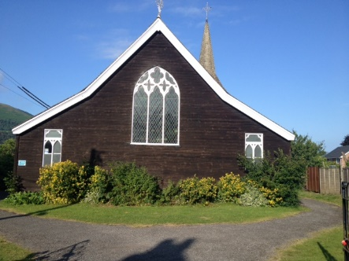
Christchurch, Abergavenny
Christchurch was built as a Chapel of Ease to St Mary’s, opening in 1880, to provide a place of worship for the workers who came to the town to build the railways. It is made of tin which is then cedar-wood clad both inside and out and Grade 2 listed as much for its interior as its exterior. We also have a hall, formerly a schoolroom, which is well used by both church and community. The small congregation works well as a team to both keep the church active and alive and to provide space for the community. Our style of worship is ‘middle-of-the-road’ Anglican, with Evensong on the first Sunday of the month and either Holy Eucharist or Matins on the remaining Sundays.

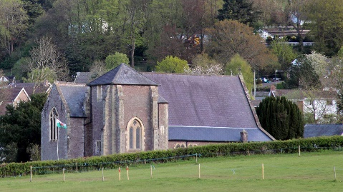
Christchurch, Govilon
Christchurch was consecrated in 1860 to enable villagers to go to church without having to cross the River Usk to St Peter’s, Llanwenarth Citra, which was then their parish church. We have a kitchen and servery at the back of the church, which is used for refreshments after the Sunday 11am service of traditional Holy Eucharist. The congregation donates regularly to the Food Bank and organises a collection of coats each year for Operation Orphan. It has a very active Mothers’ Union and holds regular fellowship and working groups as well as a Quiet Fireworks evening and Christmas craft market each year. The small church hall is used for Bible study, community events and soup lunches. There is scope for reordering the church to make it a more flexible space. There is a churchyard.

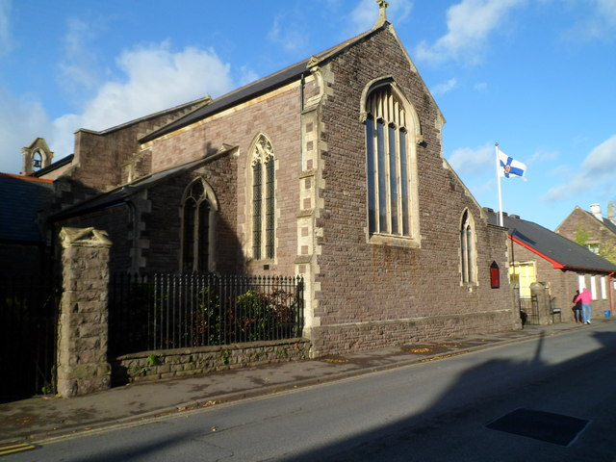
Holy Trinity, Abergavenny
A Victorian church on Baker Street flanked by eight alms houses, the vicarage (now rented out privately) and church hall, Holy Trinity was founded by Rachel Herbert for the poor of Abergavenny. The services are described as charismatic catholic with a blend of a traditional Eucharist service with contemporary praise. Apart from the regular services (Holy Eucharist on Sundays and Friday morning), there are also prayer meetings for women, monthly Open House services and monthly Sunday soup lunches. The hall is used regularly for both community and commercial purposes. The church aims to give away 10% of its income to support charities, both locally and internationally.

St Faith’s, Llanfoist
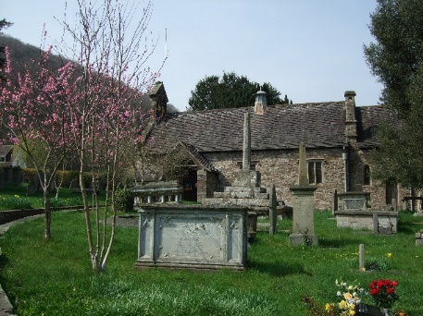
The Church of St Faith’s is a Grade 2 listed building, with parts thought to date to the thirteenth century, situated at the edge of the village near the road to Govilon. The church was extensively rebuilt in the late 1800s by Crawshay Bailey, son of the great ironmaster of the same name, whose grave is a listed monument within the churchyard. The churchyard itself is full, except for a small area set aside for cremated remains. There is a church hall some distance from the church, which was originally the Llanfoist reading room, erected in 1911 but completely refurbished in 2012. There is a primary school in Llanfoist of over 200 children, which is well supported. Our team vicar has worked extensively with the school and the children have attended the church for special services, typically at Harvest and Christingle. Members of the church participate in outreach services to Foxhunter Care Home and opens the church regularly for informal visits. We have a Sunday service each week, either Holy Eucharist or Matins, which is sometimes shared with Llanellen.
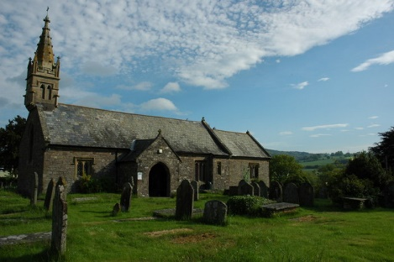
St Helen’s, Llanellen
Largely rebuilt in the nineteenth century St Helen’s church may date back to the thirteenth century, and stands strongly in the centre of the community. The village consists largely of bungalows, which tends to attract people of an older age group, and the church very much serves this demographic. The church suffered a fire in its vestry in December 2022 and, after a lot of hard work and support from the community, it was re-opened by the Rt Revd Cherry Vann, in October 2023. Bishop Cherry also dedicated a small crucifix which was in the Vestry but, despite being in the heart of the fire, survived unscathed. The regular Sunday services is either Matins or Holy Eucharist and is sometimes shared with Llanfoist.

St Mary’s Priory Church, Abergavenny
St Mary’s is a Grade 1 listed building on the site of a medieval monastery, near the town centre. Parts of the church date back to the 11th century, and it contains a range of very fine monuments as well as the internationally renowned wooden Jesse figure; and stained glass windows from the early 20th century, augmented by a stained glass window of the Tree of Jesse created in 2016 by artist Helen Whittaker. The tower contains a fine ring of ten bells, which is often used by visiting ringers. There is a strong choral tradition with a robed choir of 35 adults and children. There is a Garden of Rest for cremated remains. The church acts as the Civic Church for the town. Both church and Priory Centre are used for Diocesan events.

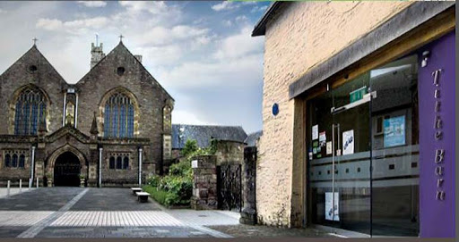
Next to the church is the Priory Centre, opened in 2000, and containing a large hall with mezzanine balcony, a kitchen and a music room. Outside are two courtyards and the medieval Tithe Barn, owned by the church, which has been converted into a visitor centre and which now houses an independently-run Wellbeing Café and counselling room. Both the Priory Centre and the Tithe Barn are marketed commercially, and a site-wide facilities coordinator is employed for this reason. St Mary’s is a member of the Major Churches Network.

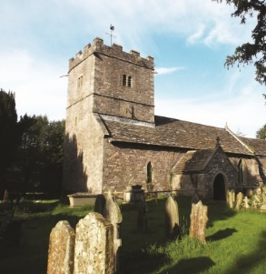
St Peter’s, Llanwenarth Citra
St Peter’s is a Grade 2* stone church just outside the town in the picturesque Usk valley. Built on an ancient site, there are two ancient Yew trees, one of which is thought to be over 1,750 years old. Although there are only three houses near the church, the church maintains a good-sized congregation and is a popular venue for smaller weddings. The church hall is ¼ mile away and is hired out and used for meetings. Occasionally, it has been used for services, for example, during the building project in 2018. The church is open from Easter to the autumn and is much visited by walkers. Our style of worship is traditional Anglican, using the 1984 Book of Common Prayer, at the Sunday service, which is either Matins or Holy Eucharist. We also hold services in Welsh. We are in the second phase of our restoration project, to restore the tower and install an accessible WC and servery. There is a churchyard, part of which is kept as a wildlife, meadow flowers areas.

The Vicarage
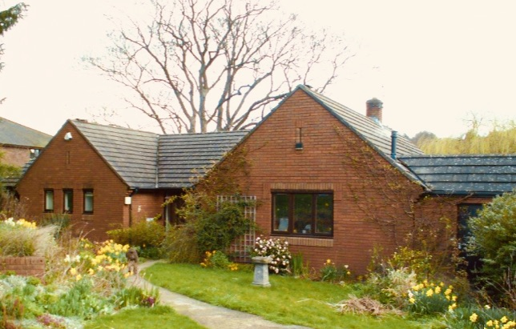
St Mary’s Vicarage, situated behind St Mary’s Priory Church, is a four-bedroomed bungalow, with large kitchen, installed in 2021 with space for a range cooker, dining room and reception room. It also includes a study and a utility room. The carpets in the study, bedrooms and bedroom hallway are in good condition, as is the parquet flooring to dining room, reception room and entrance hall. The master bedroom has an en-suite electric shower and there is a family bathroom. The house is heated by a combi-boiler. The double garage has electric doors and the property is surrounded by established gardens. Access is via a driveway alongside the Priory Centre and features electric gates. A grant is available towards furnishings and removal expenses.

Our new website (www.abergavenny.church) has just been launched but more information on St Mary’s is available at stmarys-priory.org and on St Peter’s at stpetersllanwenarth.org.uk

For an informal conversation please contact Venerable Ian Rees
on (07983 684151) or (archdeacon.monmouth@churchinwales.org.uk)

Application form and full profile available at https://monmouth.churchinwales.org.uk/en/about-us/jobs/

Applications should be submitted by email to : archdeacon.monmouth@churchinwales.org.uk

Closing date for applications: 5th November, 2024
Interviews to take place on 13th November, 2024

